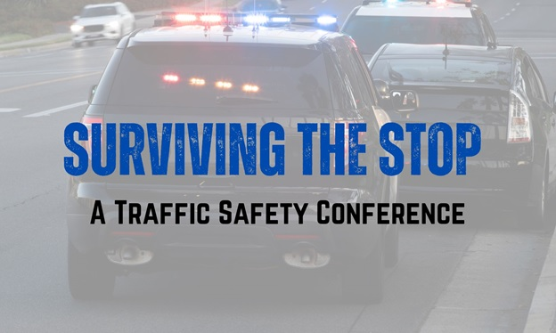
“Surviving the Stop” a Traffic Safety Conference
January 26 – 29, 2025
Grand Hotel Ocean City Maryland
Date and Time | Session | Instructor
Sunday  1/26/25  1600 - 1730 | Registration  Hotel Lobby | MHSO Staff
Monday  1/27/25  0700 - 0800 | Breakfast | Grand Ballroom  4th Floor
Monday  1/27/25  0800 - 0815 | Welcome | Dr. Timothy Kerns  Director  Maryland Highway Safety Office
Monday  1/27/25  0815 - 0920 | Officer Safety and Wellness  (Current Trends in Traffic Fatalities) | Nick Breul  Senior Program Manager  National Law Enforcement Officers Memorial Fund
Monday  1/27/25  0920 - 0930 | Break | Grand Ballroom
Monday  1/27/25  0930 - 1045 | The First Three Seconds | Robby Robertson  North Carolina State Highway Patrol
Monday  1/27/25  1045 - 1055 | Break | Grand Ballroom
Monday  1/27/25  1055 - 1230 | The First Three Seconds | Robby Robertson  North Carolina State Highway Patrol
Monday  1/27/25  1230 - 1330 | Lunch | Grand Ballroom
Monday  1/27/25  1330 - 1500 | The First Three Seconds | Robby Robertson  North Carolina State Highway Patrol
Monday  1/27/25  1500 - 1510 | Break | Grand Ballroom
Monday  1/27/25  1510 - 1700 | The First Three Seconds | Robby Robertson  North Carolina State Highway Patrol
Tuesday  1/28/25  0730 – 0830 | Breakfast | Grand Ballroom
Tuesday  1/28/25  0830 - 1000 | Advanced Vehicle CQB and  Takedowns | Robby Robertson  North Carolina State Highway Patrol
Tuesday  1/28/25  1000 - 1015 | Break | Grand Ballroom
Tuesday  1/28/25  1015 - 1215 | Advanced Vehicle CQB and  Takedowns | Robby Robertson  North Carolina State Highway Patrol
Tuesday  1/28/25  1215 - 1315 | Lunch | Grand Ballroom
Tuesday  1/28/25  1315 - 1445 | Advanced Vehicle CQB and  Takedowns | Robby Robertson  North Carolina State Highway Patrol
Tuesday  1/28/25  1445 - 1500 | Break | Grand Ballroom
Tuesday  1/28/25  1500 - 1645 | Law Enforcement  and Seatbelt Use | Sgt. Tom Morehouse  OFC. Matthew Lundquist  Baltimore County Police  Department
Wednesday  1/29/25  0700 - 0800 | Breakfast | Grand Ballroom
Wednesday  1/29/25  0800 - 1000 | Navigating the Aftermath of an Officer-Involved Shooting or Other Critical Incident | F/Sgt. Bill Gleason (Retired) &  Sgt. Renee Plumb  Prince George’s County Police Department
Wednesday  1/29/25  1000 - 1015 | Break | Grand Ballroom
Wednesday  1/29/25  1015 - 1200 | Navigating the Aftermath of an Officer-Involved Shooting or Other Critical Incident | F/Sgt. Bill Gleason (Retired) &  Sgt. Renee Plumb  Prince George’s County Police Department
Please complete the Surviving the Stop Conference Evaluation

https://www.surveymonkey.com/r/2025SurvivingtheStop
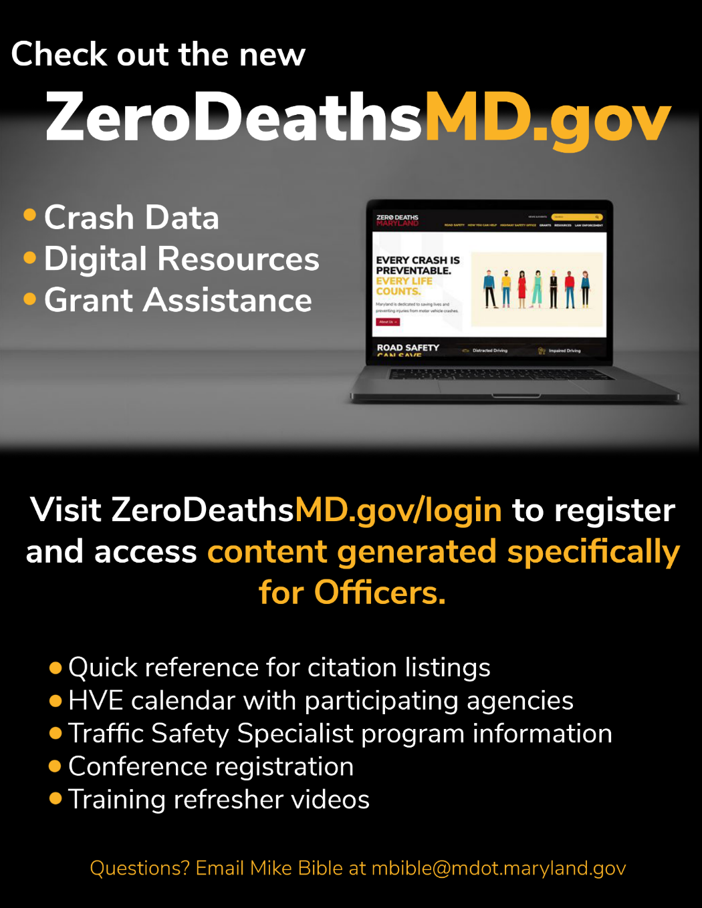

Officer Safety and Wellness
This session will provide an overview of the National Law Enforcement Officers Memorial Fund (NLEOMF) and present the 2023 fatality statistics for law enforcement officers. It will include a focused discussion on traffic-related fatalities, exploring trends and analysis findings, and insights from a tire deflation device report. Recommendations from a recent traffic safety summit will lead to a presentation on officer safety and wellness programs supported by NLEOMF.
Nick Breul is a Senior Project Manager at NLEOMF. Previously, he was the Director of the Officer Safety, Wellness and Research Division, where he analyzed line-of-duty deaths, particularly those related to traffic incidents. Nick retired from the Metropolitan Police Department (MPD) after 26 years, serving in various roles including Detective, Patrol Sergeant, and Homicide Supervisor, ultimately retiring as a Lieutenant managing the Traffic Safety Branch. He holds a BA in History from Hobart College and continues to serve as the departmental historian for the MPD.

Surviving the First Three Seconds
"Surviving the First Three Seconds" is a class designed to prepare law enforcement officers for potentially dangerous encounters by emphasizing environmental awareness and stress recognition. The program teaches participants to identify key indicators of threat through a six-step system that includes:
- Recognizing body language associated with concealed weapons.
- Identifying vehicle indicators of pre-assault situations.
- Observing clothing cues that may conceal weapons.
- Detecting pre-attack verbal and nonverbal signals.
- Developing street-level interview skills.
- Learning techniques for lie detection and overcoming deception.
The curriculum integrates disciplines; such as psychology, kinesthetics, and human behavior, emphasizing hands-on participation through exercises and practical scenarios. Designed primarily for solo officers on the road, the program aims to shift the reactionary gap from the officer to the suspect, equipping participants with essential skills to de-escalate and survive dangerous situations effectively.
Robby Robertson has 23 years of law enforcement experience, including 18 years as a patrol Trooper with the North Carolina State Highway Patrol. He has been involved in multiple task forces and was named the SPPADS International Instructor of the Year by the IACP in 2017. Currently, he works at the Training Academy, focusing on officer survival, defense tactics, and Taser training.
Robertson is a certified instructor in various disciplines, including firearms, close-quarters battle (CQB), force-on-force training, and Army Combatives. He serves on the North Carolina State Highway Patrol Use of Force board and the SPPADS Federal Use of Force advisory board.
With over 45 years in martial arts, he holds black belts in Kenpo, Taekwondo, Kali, and Brazilian Jiu-Jitsu, and has extensive training in wrestling, Muay Thai, and boxing. He has competed in 11 full-contact mixed martial arts events and over 50 Brazilian Jiu-Jitsu competitions. Additionally, he trains law enforcement and military personnel globally and is the head instructor at Team-ROC gym in Eden, North Carolina.

Vehicle Close Quarter Battle (CQB) and Combative Course
This course on vehicle close-quarter battle tactics for police officers emphasizes the importance of preparing for dangerous shooting situations involving vehicles. It highlights the need for physical and mental readiness to ensure officers have the advantage in lethal confrontations. Key topics include:
- Cover and Concealment
- Tactical Advantage
- Ambush and Defensive Situations
- Mobility and Escape
- Weapon Retention and Close-Quarters Tactics
- Best Practices for Fighting in and Around Vehicles
By understanding survivability statistics and proper tactics, officers will be better equipped to handle the challenges posed by vehicles in high-risk scenarios. The course combines classroom instruction with PowerPoint presentations, videos, and demonstrations to reinforce learning, paralleling the need for structured training in Vehicle CQB and Vehicle Combative with established team tactics.

Law Enforcement and Belt Use
This session emphasizes the importance of police officers wearing their seatbelts while on duty, and why they must get in the habit of doing so every time they’re in their vehicle. Participants will review statistics on seatbelt usage among officers and learn how effectively seatbelts reduce injuries and fatalities. The session will also address common myths about seatbelt use during patrol and outline best practices for implementation. Additionally, participants will gain techniques for safely removing seatbelts without compromising reaction time or increasing injury risk.
Sgt. Tom Morehouse, a 26-year veteran of the Baltimore County Police Department, leads the Training Section's Traffic Training Team, which educates over 1,000 students annually on traffic enforcement. He is a certified Drug Recognition Expert and Crash Reconstructionist, recognized as an expert in traffic safety topics such as alcohol and drug impairment, occupant protection, and pedestrian safety. Sgt. Morehouse is active in various committees, including the Maryland Highway Safety Office's Impaired Driving Emphasis Area Team and the Traffic Safety Committee of the Maryland Chief’s and Sheriff’s Association.

Navigating the Aftermath of an Officer-Involved Shooting
or Other Critical Incident
This program offers a holistic approach to addressing the legal and tactical challenges following an Officer Involved Shooting (OIS) or critical incident. It focuses on the personal issues officers face because of such events. The course aims to provide insights into the responsibilities of involved officers, supervisors, and agencies, particularly in their interactions with the Independent Investigations Division, while addressing the physical and psychological needs of those affected and the agency as a whole.
First Sergeant Bill Gleason is a decorated 36-year veteran of the Prince George’s County Police Department. He has held various roles throughout his career, including patrol, vice/narcotics investigations, Special Assignments Teams, Warrant Squad, Conflict Management Team Commander, and Training Instructor/Supervisor. He is a recognized expert and travels nationally to train local, state, and federal agencies on the Use of Force, Defensive Tactics, Officer Involved Shootings, Active Shooter Response, Less Lethal Weapons, and other Police-related topics. Sgt. Gleason has responded to over 300 OIS incidents and 500 high-risk incidents.
Sgt. Renee "Gunny" Plumb has had a diverse career and impactful career with the Prince George’s County Police Department since 1994, offering her a unique perspective on best practices for managing the stress and trauma faced by law enforcement professionals. Her extensive experience includes roles as a patrol supervisor, instructor, and involvement in various specialized units including Special Operations – Canine Section, Internal Affairs, Homeland Security, Crime Scene and Crisis Negotiation. Currently, as a Clinical Support Officer, she oversees peer support and special programs within the Psychological Services Division, advocating for first responder wellness and addressing issues such as PTSD and suicide.
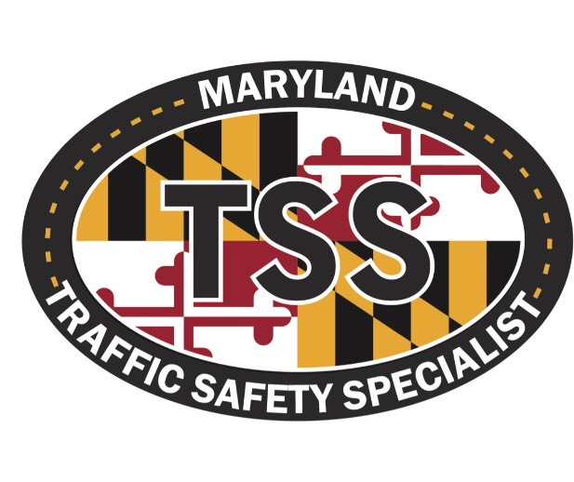

The Traffic Safety Specialist (TSS) program is a statewide recognition of police officers who have attained distinctive levels of experience, training, and proficiency in highway safety and traffic enforcement methods and procedures.
Register today:
Zerodeathsmd.gov
https://zerodeathsmd.gov/law-enforcement/law-enforcement-training-and-resources/traffic-safety-specialist/tss-designations

